Template for Collaborative Project Proposals
3rd Workshop on Proximity Sensing in Robotics at IROS 2020

Proposal Title

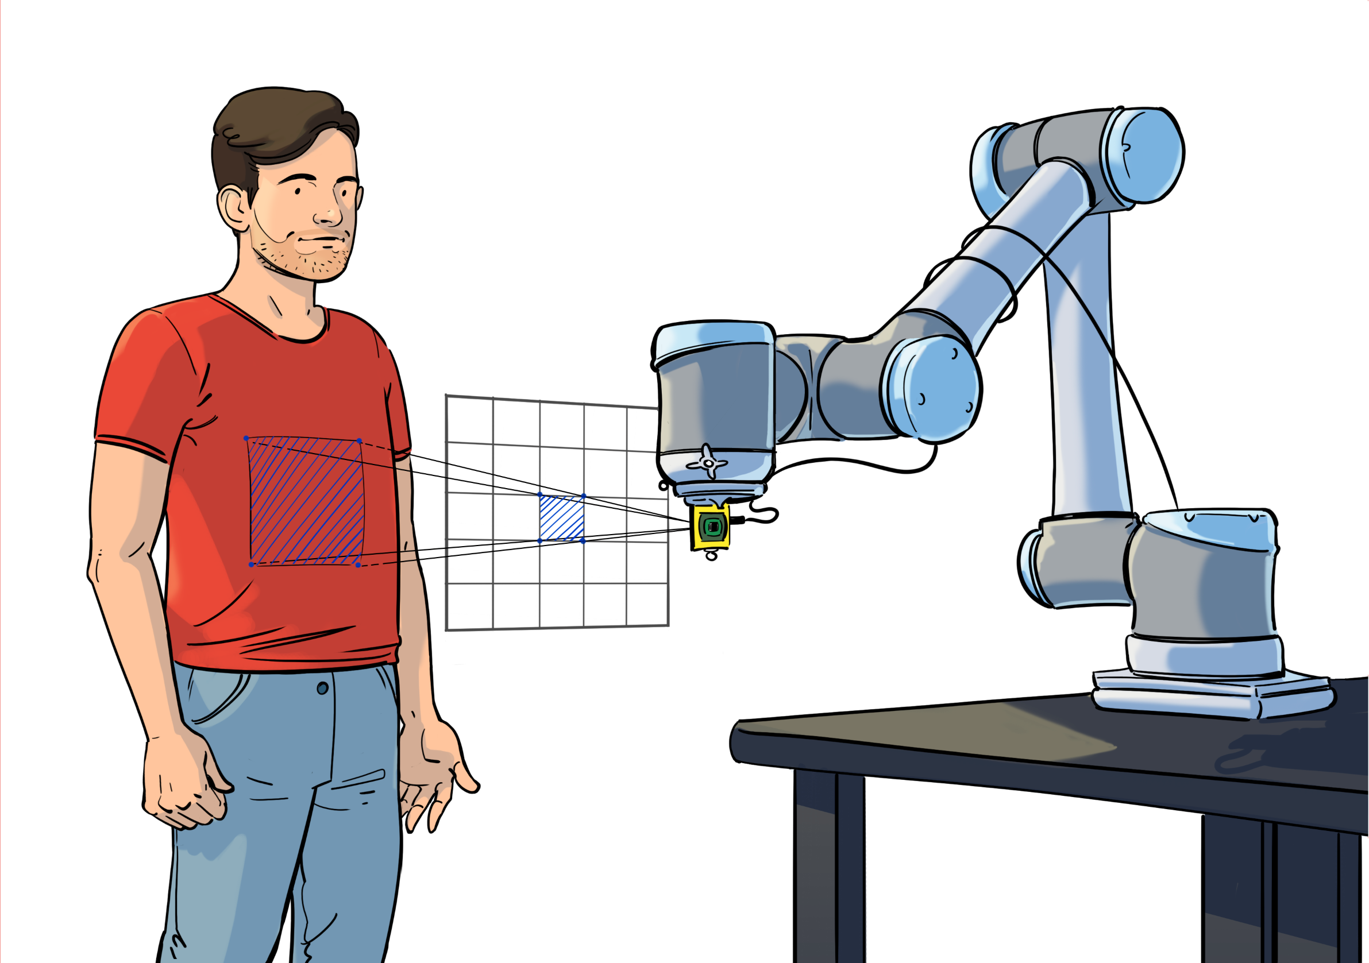
Figure 1: Example of a figure related to the proposal idea

Project Partners, Affiliations and Roles in the Project
Introduce main partners (all levels of experience welcome) and their profiles, e.g.:
Name of Researcher | Affiliation | Role / Speciality
Researcher A | Institute 1 | Hardware development for proximity sensors
Researcher B | University of City 2 | Machine Learning, Active Perception

Project Description (max. 1 page)

1) Project description and feasibility (6 points)
Description of the proposed idea, e.g. use hardware developed by Researcher A to implement a cognitive object exploration strategy proposed by Researcher B. Underline feasibility of the project in terms of the available competences, resources, etc. Add reference to Figure 1 if helpful.

2) Use of Scholarship (4 points)
How you plan to use the scholarship, for instance:
- Researcher A will fly to University of City 2 in May 2021 and stay for 3 weeks or
- submission of a collaborative paper targeted for September 2021

